**Game Instructions:**

**GAME RULES:**

1. This is a two player game and the role of one player is taken by the computer. (black - AI Agent)
2. The game objective is to fill the board with majority of your color discs.
3. The game starts out with this setup and white moves first
4. A move can be made by a player if and only if the player can flip his/her opponent's discs. These discs in the middle are then flipped the player’s disc color.
5. To flip your opponents discs means that if a disc is placed on the board, then all the other discs in all the eight directions that are bounded by the player’s discs will be changed into the color of player discs
6. The turn will be skipped if the player cannot out flip a discs(the game will end if both the players cannot do that)
7. Game can also come to end if the board is filled with discs
8. At the end of the game the number of discs on the board for each player is counted and the player with maximum number of discs is won.

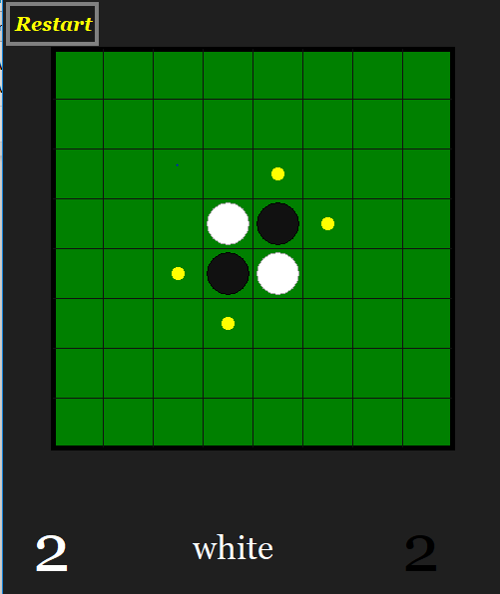

**TO BUILD AND LAUNCH GAME**

1. Download and install Python3
2. Open folder OthelloAI
3. There are 4 python files : main-game.py, game_cavas.py, gui.py and moves.py
4. Run file main-game.py
5. Choose a game level to begin the game

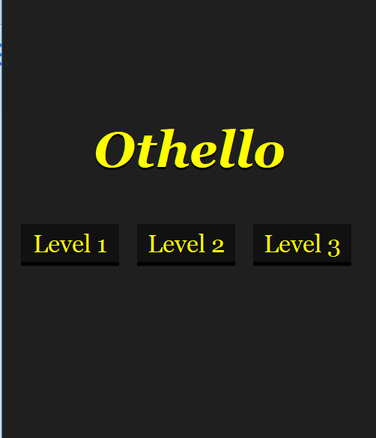

f. Scores are the number of discs of that color on the whole board.

g. Valid moves are displayed by yellow discs.

